IAC Journal Template (Time New Roman: 17)
Name of Authorª
ª Name of Affiliation
Nishi-Waseda Bldg. Nishi-Waseda, Shinjuku-ku,
TOKYO JAPAN
Abstract
IAC or International Academy of CIO was founded in 2006 in Japan by co-founders included Japan, USA, Indonesia, Philippines, Switzerland and Thailand. Members and alliances are evolving to include economies in all regions such as China, Cambodia, Holland, India, Korea, Laos, Hong Kong, Macao, Peru, Singapore, South Africa, Taiwan, UK, Viet Nam, Italy, Russia and etc.
Keyword: IAC, CIO,…
- Heading 1

Text
- Heading 1
  - Heading 2

  - Heading 2

Table 1: Name of Tables

Column 1 | Column 2 | Column 3

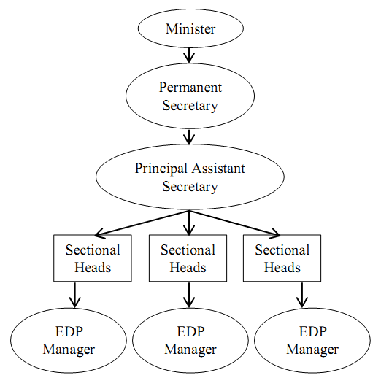
Figure 1. Name of Figure
Source:
References:
[1] Aladwani, A.M., Palvia, P.C., Developing and validating an instrument for measuring user-perceived web quality. Information and Management 39 (6), 2002, pp.467–476.
[2]

